Derivation of 3d rotation matrix:

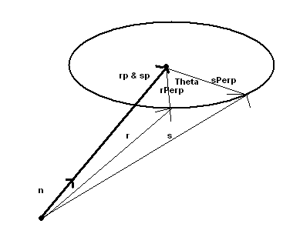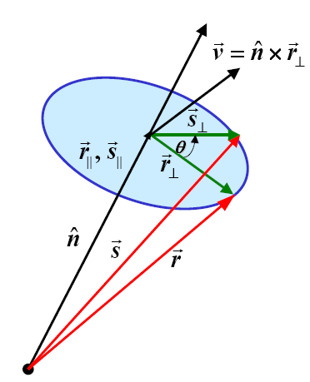

- rotation of vector r theta degrees and around vector n and becoming vector s
- rp = r-parallel = n * r = sp = s-parrallel = n*s (since rotation doesn’t change length)
- rPerp = r-Perpendicular and sPerp = s-Perpendicular

Find s:
Since I know r, the goal is to get everything in terms of r.
s = sp + sPerp => s = rp + sPerp

To find sPerp, let’s create a plane that sPerp is on with two basis that I know.
I can get one (call it V) by doing a cross product () with n and rPerp, which will produce a vector that is perpendicular to rPerp and n. So our two new basis can be rPerp and this new vector V.
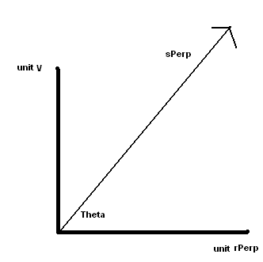
with some good old trig I get:
sPerp = |sPerp|*cos(θ)*unit_rPerp + |sPerp|*sin(θ)*unit_v
Since sPerp and rPerp are on a circle, I know that their lengths are the same. Also I know the length of V is the same as rPerp because of a property of the cross product. Namely, |n  rPerp| = |n|*|rPerp|*sin(alpha), n’s length is one and the angle betIen them is 90 degrees and sin(90)=1, thus |V|=|rPerp|
This lets us write sSperp like this:
sPerp = |rPerp|*cos(θ)*unit_rPerp + |v|*sin(θ)*unit_v
- sPerp = cos(θ)*rPerp + sin(θ)*V

Rewrite s:
s = rp + cos(θ)*rPerp + sin(θ)*V
before I write everything in terms of r, note that (n  rPerp) is equal to
(n (r-rp)) => (nr - nrp) and since rp is in the same direction as n, nrp is the 0 vector, and I’re left with nr. so V is also nr!

s = (n• r)* n + cos(θ)*(r - (n• r)* n) + sin(θ)*( nr)

Using the tensor product I can rewrite (n• r)* n as M*r, where M is matrix that when multiplied with r produces (n• r)* n.
r = (rx,ry,rz) and n= (nx,ny,nz)
(n• r)*n=((rx*nx+ry*ny+rz*nz)*nx, (rx*nx+ry*ny+rz*nz)*ny, (rx*nx+ry*ny+rz*nz)*nz)
- (rx*nx*nx+ry*ny*nx+rz*nz*nx, rx*nx*ny+ry*ny*ny +rz*nz*ny,
rx*nx*nz+ry*ny*nz +rz*nz*nz)
=>
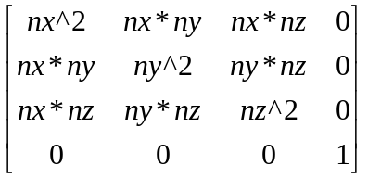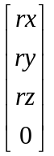 = M*r

so now I have:
s = M*r + cos(θ)*(r - M*r) + sin(θ)*( nr)
- s = M*r + cos(θ)*r – cos(θ)*M*r + sin(θ)*( nr)
- s = (1-cos(θ))*M*r + cos(θ)*r + sin(θ)*( nr)

Next I’ll write nr also as a matrix (say P) multiplied by r.
nr =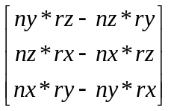

=>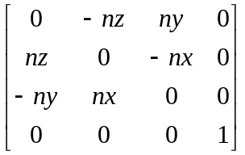=P*r
So now I have:
- s = (1-cos(θ))*M*r + cos(θ)*r + sin(θ)* P*r
since (1-cos), cos and sin are scalars, simply make them scalar matrices!
- s= [(1-cos(θ))*M + cos(θ)*I + sin(θ)* P]*r
- Rotation Matrix = [(1-cos(θ))*M + cos(θ)*I + sin(θ)* P]

Which is:
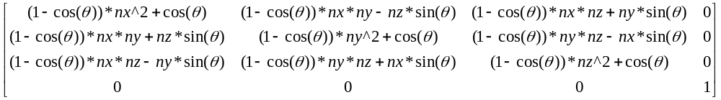
=>

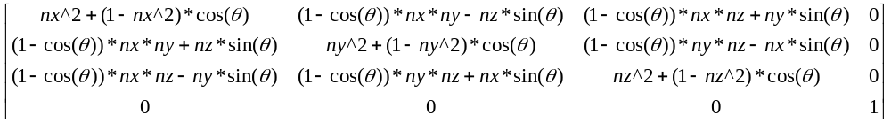
thus I have the Rotation matrix!

Note: If I plug in the basis vectors from the 3D Cartesian coordinate system I’ll get the three rotation matrices that rotate about an axis.
Put n = {0,0,1} in and we get:

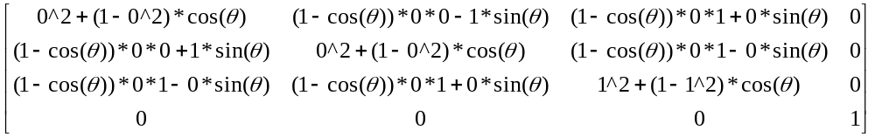
=>
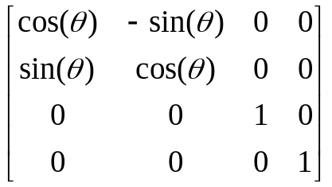 => which is the Rotation matrix about the z axis!

Put n = {0,1,0} in and we get:
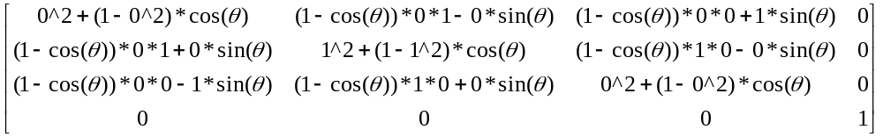
=>
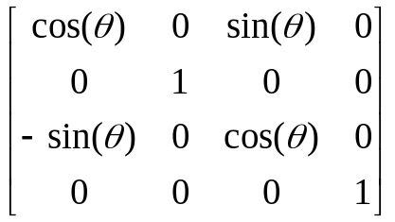=> which is the Rotation matrix about the y axis!

Put n = {1,0,0} in and we get:

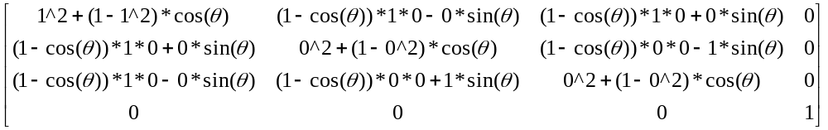
=>
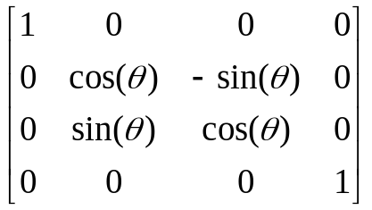=> which is the Rotation matrix about the x axis!

Note: That if you rotate -θ degrees about –n you will have the same rotation as rotating θ degrees about n.

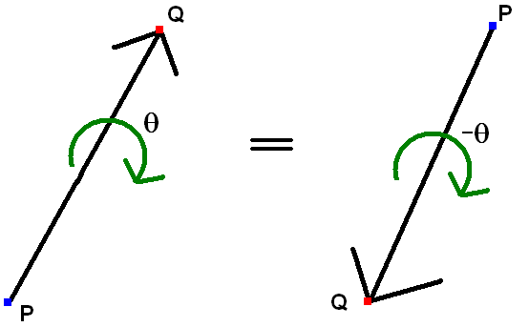
Put your eye at Q and rotate +θ degrees is counterclockwise and -θ degrees is clockwise, and you will be doing the same rotation.

Proposition to Get Rid of Trig and Square Root calls
If I know vector s (the final vector from the rotation) then I can easily get rid of the trig and square roots.

Let vector V = rs and remember that vector n=rs/(|rs|)
Cos(θ)=r•s/(|r|*|s|), |r|=1, |s|=1 => Cos(θ)=r•s
Sin(θ)=|rs|/(r||*|s|), |r|=1, |s|=1 => Sin(θ)=|rs|
|V|=|rs|=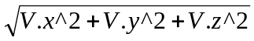=Sin(θ)
V•V=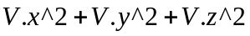
n.x = 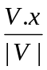 , n.y = 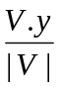 , n.z = 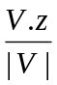

n.x*n.x = 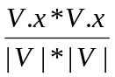 => 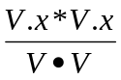, n.y*n.y = 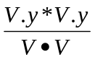, n.z*n.z = 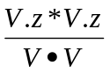,
n.x*n.y = 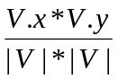 => 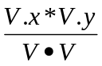, n.x*n.z = 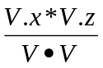, n.y*n.z = 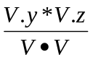

n.z*Sin(θ) = *|rs| => *|V| => V.z
n.y*Sin(θ) => V.y
n.x*Sin(θ) => V.x

Now I can rewrite the rotation matrix in terms of vector V, which will be without trig and square roots.

